

National Textile University
Department of Computer Science
Subject
Mobile Application
Submitted to:
Rehan Sarwar
Submitted by:
Hadi Muhammad
Registration Number
23-NTU-CS-1160
lab No.
01
Semester
6th

Lab Plan – 1
1. Create a Flutter Project

Shortcut key → Ctrl+shift+p

- Create a Stateless Widget (stle) and Add AppBar to your Project.
- Change the color of the Appbar.
- Align the Text on the Appbar at center.
- Add you name at the center of the screen.
Code:
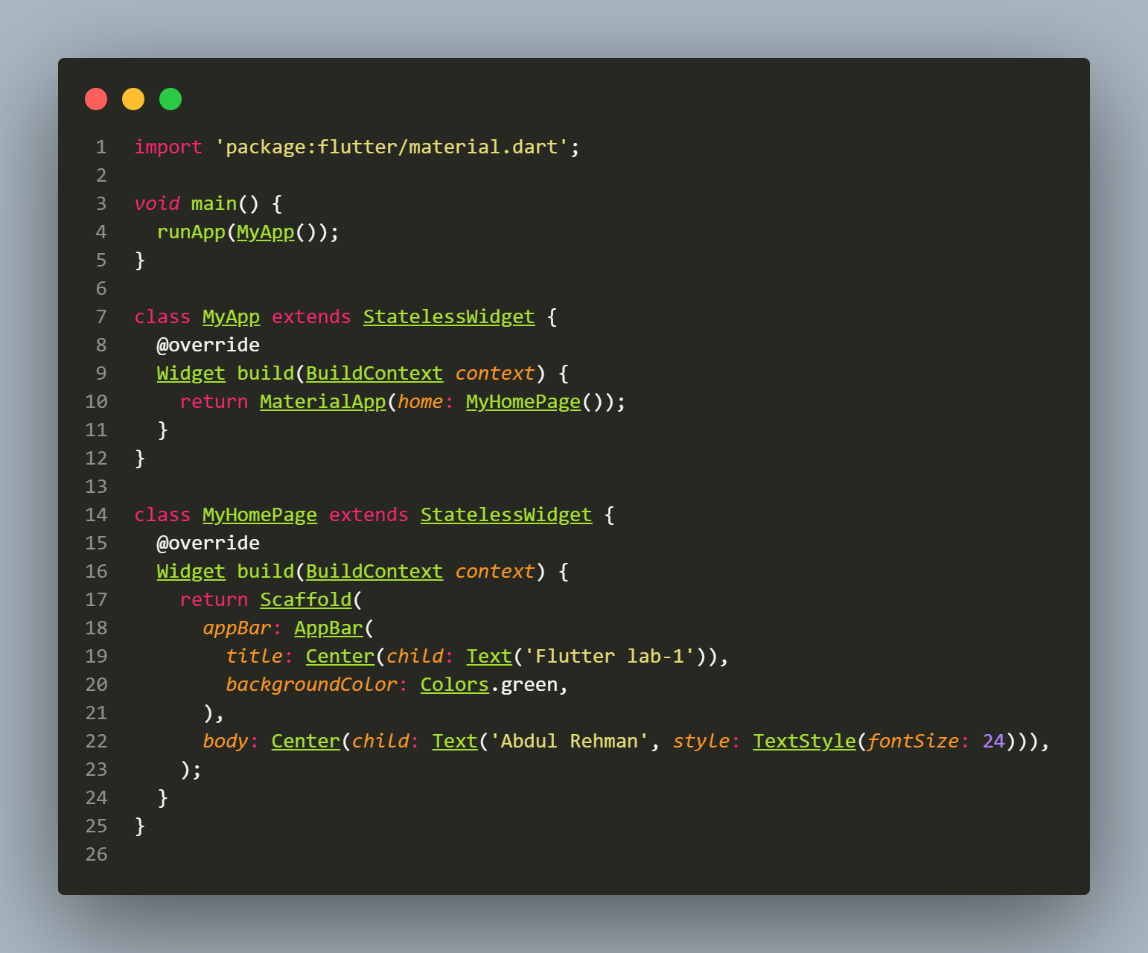

Output:
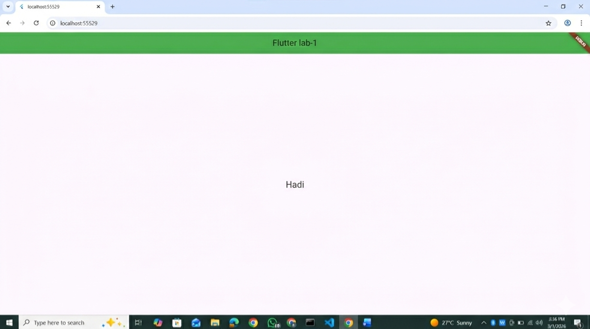

Note: If you are not adding the Material App Design
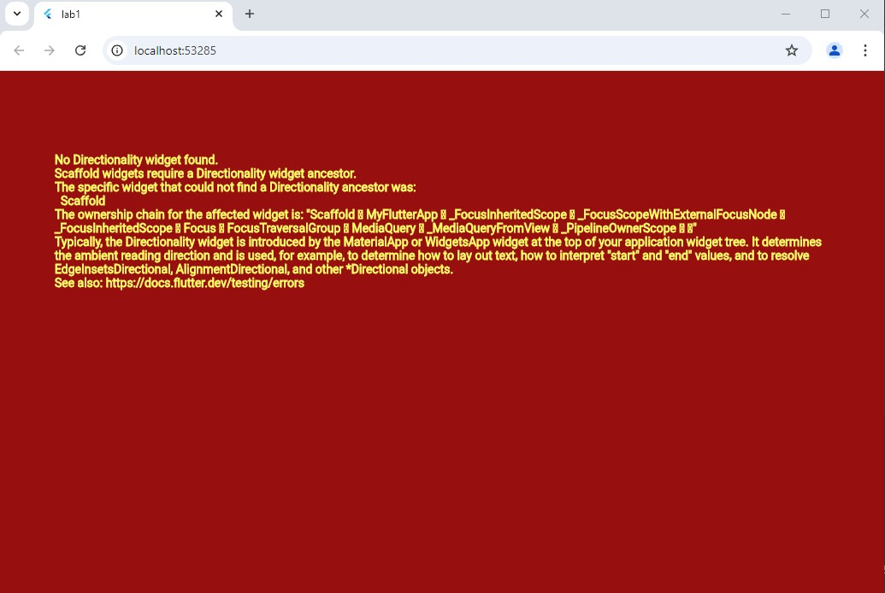

- Design the UI Layout:
  - Inside the `Scaffold`, create a `Column` widget.
  - Add a `Row` widget as the first child of the `Column`.

- Use Size box for spaces

Assets and Network Images
- Download the image form google
- Add assets to pubspec.yml file
- Add image to your Project by using assets
- Add Image to your project by using Network Image
